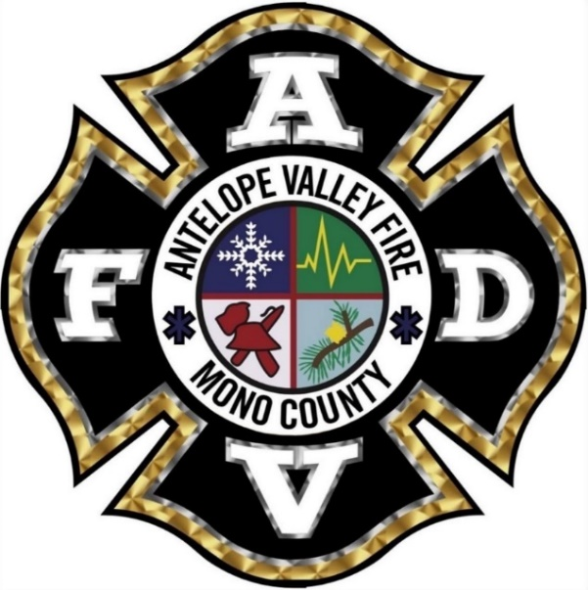
Core Values
Integrity: We are honest, trustworthy and accountable. We follow department values and strive never to bring negativity or negative attention to the Fire District.
Customer Service: We treat everyone with respect and dignity. We are professional in our interactions with the public and treat everyone as a neighbor.
Accountability: We do things to the best of our abilities, we stand behind it and we take responsibility for our actions.
Loyalty: We ride for the brand and promote buy-in and support. We will do nothing to embarrass the department or other members of the department.
Teamwork: We each bring our own skills and experience yet recognize that we are better together. We work together in a positive manner and teach as well as learn from each other. We support each other in bad times and celebrate each other’s good times. Always, we work for the common good.

