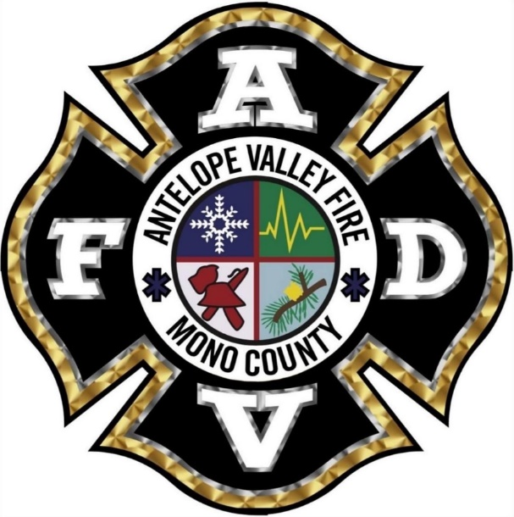
Antelope Valley FPD Vision Statement

We will support our Mission and become the area model for fire services by recruiting quality people, giving them excellent training and modern equipment, and working for the common good, both within and outside the department.

