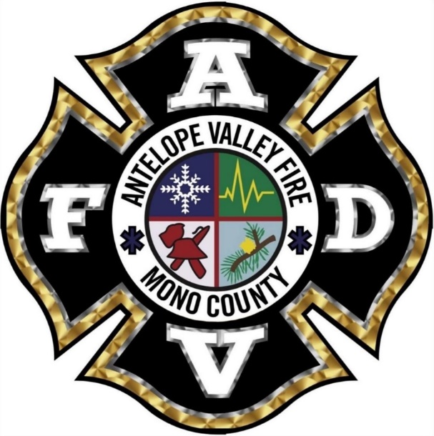
Antelope Valley FPD Mission Statement

The mission of the Antelope Valley Fire Protection District is to protect and serve the citizens and visitors of the Antelope Valley by providing fire prevention and suppression, safety education, emergency medical care, and respond to the community’s emergency needs in a safe, professional, courteous, and efficient manner as resources allow.

